Ontario Cancer Research Ethics Board
MaRS Centre, Suite 510 | 661 University Avenue
Toronto, Ontario | Canada M5G 0A3
416-673-6649 or 1-866-678-6427 ext. 6649 | www.ocreb.ca

Monthly Centre Web/Teleconference Meeting Summary
October 21, 2022 @ 9am

Sites: | - Cambridge Memorial Hospital  - CHEO, Ottawa  - Grand River Hospital  - Hamilton Health Sciences  - Health Sciences North, Sudbury  - Hospital for Sick Children, Toronto  - Humber River Hospital, Toronto  - Kingston General Hospital  - Lakeridge Health, Oshawa  - London Health Sciences Centre  - Markham Stouffville  - Michael Garron Hospital, Toronto  - Niagara Health System  - North York General Hospital | - The Ottawa Hospital  - Royal Victoria, Barrie  - St. Joseph’s Healthcare, Hamilton  - Sinai Health System, Toronto  - Southlake Regional Health Centre, Newmarket  - Sunnybrook Health Sciences Centre, Toronto  - Thunder Bay Regional Health Sciences Centre  - Trillium Health Partners, Mississauga  - UHN (PMCC, TGH, TWH), Toronto  - Unity Health (St. Michael’s/St. Joseph’s), Toronto  - William Osler Health Centre, Brampton  - Windsor Regional Hospital  - Women’s College Hospital, Toronto
OCREB: | Beren Avci, Aurora de Borja, Roxanne Fernandes, Hind Amzil, Meera Sidhu, Alison van Nie, Natascha Kozlowski (ED), Jacqueline Limoges(Chair)

NOTICES
New staff including Executive Director of OCREB, and Chair and Vice Chairs of the REB -
ED: Natascha Kozlowski
Chair: Jacqueline Limoges
VChair: Mihaela Mates
VChair: Jeff Doi
VChair: Ron Grant

New Staff:
Meera Sidhu
Roxanne Fernandes
Hind Amzil

Ongoing staff:
Aurora de Borja
Beren Avci
Alison van Nie

French language ICF translations
OCREB is working with sponsors and PAs to try to ensure that the French language translation of the trial consent form(s) are provided by the sponsor once the English language version of the consent form(s) has received final approval.

November meeting date changed + submission of PCRs and CCRs
Meeting date: November 18th
Submission of new studies, continuing review applications and amendments to ongoing studies: November 1 deadline

Note: Submission of continuing review applications for the October 14th meeting was updated to include studies expiring up to November 17th [previously Nov. 10th]

**Deadline for the Nov 18th meeting is still Oct. 25th
Please see OCREB.ca website for list of studies due for renewal/continuing review:

https://ocreb.ca/wp-content/uploads/2022/09/OCREB_Meeting_Schedule_2022-1.pdf

COG studies/short form ICFs
The Children’s Oncology Group Trials [COG] which OCREB reviews, have been requested by the US regulators/sponsors to implement applicable short form consents for trials in which the consent is not translated in the language that is spoken by the participant/guardian and for which interpretation of the consent is required. This is a recommendation from the OHRP and the FDA. The short form is intended to provide the main elements of consent in the language that is spoken by the participant/guardian; the main consent form which is not translated provides information specific to the trial and all the required elements for consent as per the applicable guidance and regulations. The short form consent is signed by the participant/guardian and the main consent is interpreted and signed by the interpreter and the person obtaining consent – if implemented for the COG trials OCREB will require that the participant/guardian continues to sign the main consent also.
As per Canadian guidance and regulations short form consents are not required.

SOC risks in ICFs
Statement on the Investigational Use of Marketed Drugs in Clinical Trials
Notice to Stakeholders: Statement on the Investigational Use of Marketed Drugs in Clinical Trials - Canada.ca

REMINDERS

Upcoming Amendments
Please remember not to submit an amendment to the protocol at the time of the submission of the PIA.
Naming conventions
When uploading study documents to the application, please be aware that in most cases, the document name as it appears in the approval letter automatically is taken from the file name. If you want to change the document name, you must ensure that the File Name is correct/corrected.

File names should be consistent, short but descriptive, with no special characters or spaces. Include a version or edition number in the file name and add the version date to the appropriate box in the application. (Do not include a date in the File name).

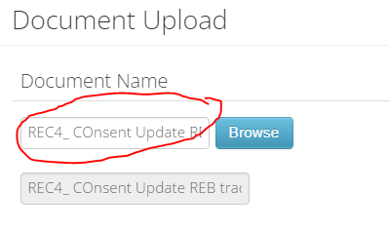
Examples:
IB: the document name is as it appears in the document: e.g., pembrolizumab (MK 3475) Edition 22
PM: gemcitabine; IB: nivolumab Addendum 01 to Edition 21
Protocol: Include Protocol ID & version number - e.g., Protocol MK-4801 version 3.0
PROs/Screenshots: include the names of each Questionnaire: e.g, EORTC QLQ-C30; EQ 5D 5L, etc.

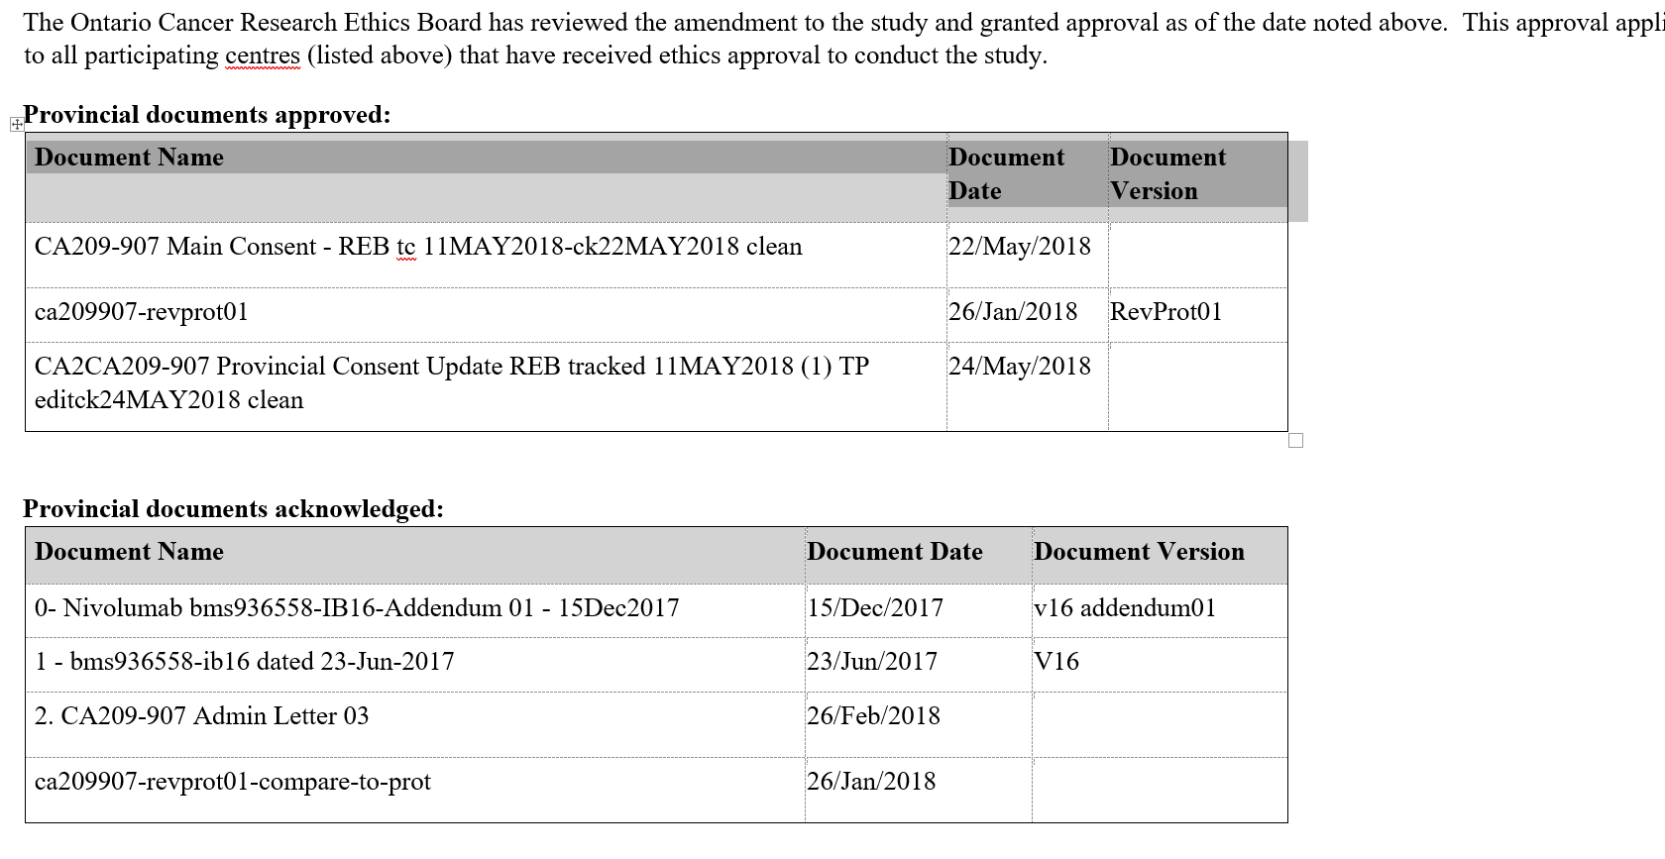

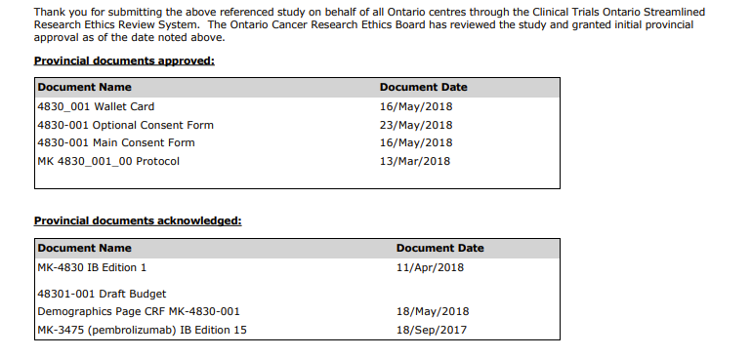

Use of consent templates
OCREB is committed to maintaining consistency and integrity in the use of the consent form and has ongoing work with many of our sponsors (pharma) to resolve any issues that arise between sponsor and REB requirements.
The pre-approval for specific language from sites and sponsors has been minimized with the launch of the current consent template [launched during covid] which has simplified and harmonized consent content and practices within our scope.
OCREB remains committed to focusing on appropriate language in the consent and has adapted some of the previous language to ensure that it is inclusive as much as possible.

Pre-approved administrative language for all centres: the addition of contact
information, the removal of instructional text, addition of information re procedures taking place outside the centre as applicable, and the approval for centre specific changes to the ICF Compensation language
e.g., Information re procedures taking place outside the participating centre:
- If applicable: Centre-specific: only use and adapt the next paragraph if the following will be required.
The following (treatments/procedures/tests) for this study may take place (closer to your home/at another location). The information from these (treatment/procedures/tests) will be sent to your study doctor.
- (List the treatment/procedure/tests that are authorized to take place at the above location/centre).
- If appropriate, insert a description of any compensation for participation or reimbursement for expenses.
- You will be reimbursed for study-related expenses such as [specify, e.g., parking]

Pre-approved centre-specific language
Implementing the most recent version of the provincial consent – no changes to the version date

If you have questions regarding the implementation of the consent form when submitting a PIA please contact Alison van Nie. For ongoing studies please contact the responsible REC.

Determining when CAMs are needed
The submission of CAMs is uncommon. Unlike requirements for studies submitted through CTO to other REBs, OCREB, as a central REB does not require the submission of centre-specific consents or amendments to implement a provincial amendment. Provincial approval extends to all participating centres.

Examples of CAM submission include for e.g.:
- Change in COI; change in reimbursement
- submission of a translated participant material unavailable at the provincial level
- a change in the centre PI and/or a change to the centre study contact

Invitation for consultations with OCREB staff
For e.g.,
- prior to the submission deadlines
- prior to other submissions – such as amendments, protocol deviations
- for new applicants prior to submissions

Direct email opportunity
- RECs are available to respond to requests for consultations which can be conducted via email or by scheduling a call
- Correspondences in CTOstream – please note that if you use the correspondence function to ensure a timely response please notify the REC who may be unaware that correspondence has been added

OCREB Membership Changes
The current and archived OCREB membership lists are posted on the OCREB website on the “Meetings and Membership” page. The list was last updated in October 2022.

NEW STUDIES
Other Potential New Studies: contact OCREB if you are planning new PIA submissions

CONTINUING REVIEW APPLICATIONS
Please review the information on ocreb.ca for updated information regarding submission requirements/deadlines.

NOTEWORTHY ITEMS
A place for sharing new information, updates and other noteworthy items affecting the research community…

- Health Canada announces: GUI-0043: Risk classification guide for observations related to inspections of clinical trials of human drugs was published on September 29, 2022, and can be found on the Health Canada website at https://www.canada.ca/en/health-canada/services/drugs-health-products/compliance-enforcement/good-clinical-practices/guidance-documents/risk-classification-observations-inspections-clinical-trials-guide-0043.html. This document replaces the Classification of observations made in the conduct of inspections of clinical trials that was published online on August 29, 2008.

This guide:
- describes how inspectors classify clinical trial inspection observations based on risk [critical – major-minor]
- describes how the overall rating is assigned to an inspection, when applicable, and includes situations that may result in a non-compliance (NC) rating
- promotes consistency in assigning risk ratings of inspection observations and in the overall inspection rating
- provides examples of inspection observations

- Health Canada retention of study records:
Based on the following notification (also available at Notice: Period reduced for keeping clinical trial records for drugs and natural health products - Canada.ca), it seems that that trials with ongoing retention criteria can apply the new 15 year rule:

Notification:
Health Canada is reducing the retention period for clinical trial records for drugs and natural health products from 25 years to 15 years under the Food and Drug Regulations and Natural Health Products Regulations. This change takes effect on February 11, 2022. We will be updating the policies, guidance documents and other documents accordingly.

HC: the publication date of the announcement has been included, as this is the date the amendment took effect. As such, HC indicated that any trials that were approved prior to that date (February 11, 2022) the record retention for 15 years applies. It also applies to trials authorized from February 11 and onwards. The February 11 date was included in order to indicate that trials authorized prior to this amendment date and have exceeded the 15 year record retention by this date no longer have to be retained.
e.g., if a clinical trial has exceeded the 15 year retention period as of February 11, 2022, the records can be destroyed.

What sponsors need to know
The period for keeping records starts on the date the record is created. To simplify the process, sponsors may choose to "start the clock" for keeping all study records when the trial is completed or terminated. We are consulting stakeholders on the start date through consultations for the plan to modernize the regulation of clinical trials.
The requirement to keep records for 15 years would apply to sponsors of:
- clinical trials of all drugs and natural health products with ongoing record retention obligations prior to February 11, 2022
- any new clinical trials authorized on or after February 11, 2022
We will update documents over time to reflect the change to a 15-year record retention period.

Next Web/Teleconference Session
Please review information on ocreb.ca for news of upcoming teleconferences.
TBD@ 9am

